GITHUB WIKI PAGE DATA
Cardington App ‐ Configuration
Description
The intent of this project is to provide wrapper for lawson DME services and provide a Rest API in order to allow other application at HCA to access lawson data in a RESTful manner
Swagger
DEV : http://xrdcldappobp01a.unix.medcity.net:8082/cardington/swagger-ui.html
Cardington service Status/Restart steps
Status - sudo /usr/bin/systemctl status cardington.service
Stop - sudo /usr/bin/systemctl stop cardington.service
Start - sudo /usr/bin/systemctl start cardington.service
Servers
- Cardington Dev : xrdcldappobp01a.unix.medcity.net
- Cardington QA Node A: xrdclqappobp01a.unix.medcity.net
- Cardington QA Node B: xrdclqappobp01b.unix.medcity.net
- Cardington Prod Node A: xrdclpappobp01a.unix.medcity.net
- Cardington Prod Node B: xrdclpappobp01b.unix.medcity.net
cardington user profile is set in this /home/cardington/.bash_profile This is where all the cardington related passwords are configured.
Similarly onbase related passwords and configurations are maintained in /home/obpsvc/.bash_profile.
If any updates needs to be done in the bash profile, source the profile to reflect the changes and restart the app accordingly.
In the home directory of the server, execute - source ~/.bash_profile
Dynamic Logging Updates - Actuator Configuration
Cardington has Actuator setup which helps in dynamically changing the endpoint loggers without needing to restart the app/service.
Below are the steps to dynamically update the log levels and validate the configuration
Verfiying the log levels of endpoints and classes in Cardington
curl "http://xrdcldappobp01a.unix.medcity.net:8082/cardington/actuator/loggers/com.hca.cardington.service.EmployeePTOService"
curl "http://xrdcldappobp01a.unix.medcity.net:8082/cardington/actuator/loggers/com.hca.cardington.service.EmployeePTOService"
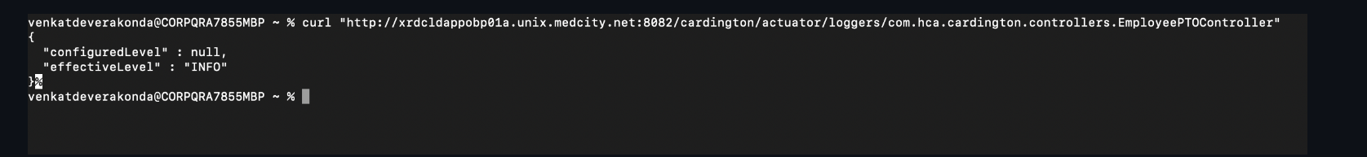
Above command will print the current log level of the mentioned class.
Validate logs for endpoint you would like to verify the logs before changing the log level to debug by invoking the endpoint using Swagger.
tail -f /opt/cardington/log/cardington.log
tail cardington logs and verify the logs information.
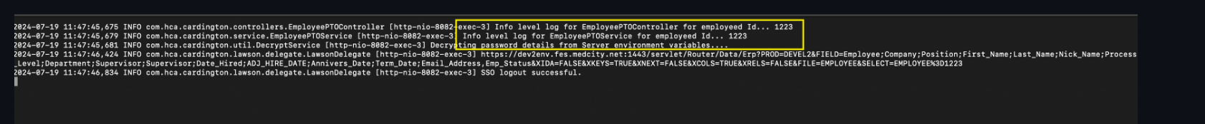
Update log level configuration
curl -X POST "http://xrdcldappobp01a.unix.medcity.net:8082/cardington/actuator/loggers/com.hca.cardington.controllers.EmployeePTOController" -H "Content-Type: application/json" -d '{"configuredLevel":"DEBUG"}'
curl -X POST "http://xrdcldappobp01a.unix.medcity.net:8082/cardington/actuator/loggers/com.hca.cardington.service.EmployeePTOService" -H "Content-Type: application/json" -d '{"configuredLevel":"DEBUG"}'
Above commands will update the log level configuration on the app to the mentioned classes without having to restart the app/service.
Validate log level configuration for the above dynamic configuration
curl "http://xrdcldappobp01a.unix.medcity.net:8082/cardington/actuator/loggers/com.hca.cardington.controllers.EmployeePTOController"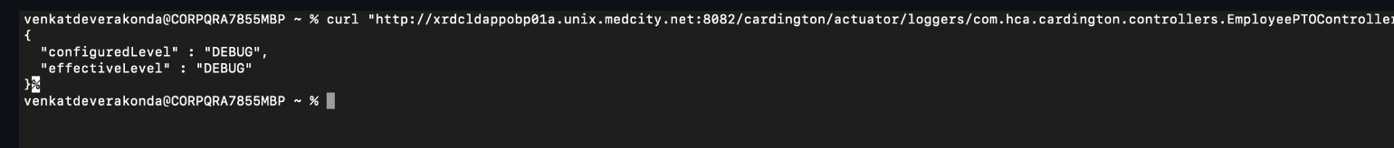

Validate logs for endpoint you would like to verify the logs after changing the log level to debug by invoking the endpoint using Swagger.
tail -f /opt/cardington/log/cardington.log
tail cardington logs and verify the logs information.
GITHUB README PAGE DATA
The intent of this project is to provide wrapper for lawson DME services and provide a Rest API in order to allow other application at HCA to access lawson data in a RESTful manner
Tech Stack
- Spring Boot 2.5.6
- Open Jdk 1.8
Swagger
DEV : http://xrdcldappobp01a.unix.medcity.net:8082/cardington/swagger-ui.html
DevOps
This application is currently hosted along with other ERP services, OnbaseProxy,Trinisys etc in a shared server space
Application is currently deployed into /opt/cardington and is packaged as a spring boot executable jar. Systemd service carding.service is configured to launch the executable jar with appropriate environment arguments for each environment
This app is deployed via github actions. The primary workflow is "Build and Deploy" from maven.yml
There are also other actions that can be run:
- Restart Cardington - stop/start/status. The same way as Build and Deploy without changing the code
- Stop Cardington - Stop the app and show status (status will fail if successfully stopped)
- Start Cardington - Start the app and show status
- Cardington Status - Show the status of cardington (will fail if the app is down)
There are several GH environments defined (see below for server info):
- DEV - can be used to deploy or restart actions. No protections
- QA Node A, QA Node B - can be used to deploy or restart. Requires approval
- QA Node A restart, QA Node B restart - Can be used to restart only. No protections
- Prod Node A, Prod Node B - can be used to deploy or restart. Requires approval
- Prod Node A restart, Prod Node B restart - Can be used to restart only. No protections
Service Management
Cardington uses spring actuator to expose actuator end point in order to expose service metrics and also provide logging management
- http://xrdcldappobp01a.unix.medcity.net:8082/cardington/actuator
- http://xrdcldappobp01a.unix.medcity.net:8082/cardington/actuator/loggers
Environments
- DEV : xrdcldappobp01a.unix.medcity.net
- QA : xrdclqappobp01a.unix.medcity.net, xrdclqappobp01b.unix.medcity.net
- PROD : xrdclpappobp01a.unix.medcity.net, xrdclpappobp01b.unix.medcity.net
Build
mvn -B package --file pom.xml
Note: The pom file has several JAXB dependencies commented out. If you get exceptions, you may need to uncomment.
Running locally (without conf files)
java -jar -Dspring.profiles.active=DEV -Dsun.misc.URLClassPath.disableJarChecking=true -Dlogging.level.root=DEBUG ./target/Cardington-1.0.0-SNAPSHOT.jar
Log files will be in /opt/cardington/log
Carington uses lombok for slf4j log, getters and setters to reduce redundancy in code. Below is the link to configure and install lombok in eclipse or intellij. https://www.baeldung.com/lombok-ide
Design
Due to the use of the lawson jar file (which requires a u/p), this necessitates the use of service accounts. In order to limit the scope of the service accounts, each end point will be assigned it's own service account with only the security necessary to return the data for that endpoint. For example, the vendor endpoint is assigned a service account that only has access to the vendor table in Lawson.
Below not yet implemented
To complete the access control, there are two additional security components. The first is authorization to Cardington itself. The second is a mapping that controls which endpoints a user is allowed to access. For example, hrserviceacct may be a valid account in cardington, but it should not be permitted to access the vendor endpoint, wheras the timed service account should be able to access both the vendor and employee endpoints.
ONE NOTE DATA
Server Details
Unix Servers | Name | Host | Port | IP
Cardington | Cardington Dev | xrdcldappobp01a.unix.medcity.net | 22 | 10.27.102.73
Cardington | Cardington QA Node A | xrdclqappobp01a.unix.medcity.net | 22 | 10.27.102.74
Cardington | Cardington QA Node B | xrdclqappobp01b.unix.medcity.net | 22 | 10.27.102.75
Cardington | Cardington Prod Node A | xrdclpappobp01a.unix.medcity.net | 22 | 10.27.82.103
Cardington | Cardington Prod Node B | xrdclpappobp01b.unix.medcity.net | 22 | 10.27.82.104

Down-Stream Application → Infor GHR (Landmark)
What is Infor GHR?
A modern enterprise Human Capital Management platform built on the Infor Landmark technology stack that acts as the primary system of record for all employee lifecycle events, organizational structures, and strategic HR operations.
Core Modules & Features
1. Talent Acquisition & Onboarding
- Candidate Sourcing: Tracks applicants through recruiting pipelines, background screenings, and offer letter generation.
- New Hire Provisioning: Collects tax documents, direct deposit details, and emergency contact records before day one.
2. Global Human Resources
- Personnel Action Tracking: Logs core HR events including hires, transfers, promotions, and legal name changes.
- Position Management: Dictates organizational hierarchies, vacant job requisitions, and reporting supervisor structures.
3. Employee & Manager Self-Service
- Profile Management: Empowers staff to directly update contact information, view benefit elections, and request time off.
- Supervisory Approval Workflows: Routes personnel action requests to managers for multi-tier digital signatures.
Mid-Stream Application → Cardington (IPA Middleware)
What is Cardington (IPA Middleware)?
A robust workflow orchestration engine (Infor Process Automation) configured to securely intercept data mutations in GHR, execute system validation checks, and securely synchronize records down to legacy Lawson application screens.
Core Modules & Features
1. Event Orchestration & Transformation
- Landmark Trigger Nodes: Listens to the GHR database for specific business classes (e.g., Employee, Work Assignment) to spin up real-time sync processes.
- Data Mapping Engines: Converts modern Landmark object schemas into the precise field-string dimensions required by legacy platforms.
2. Lawson Read Interface (DME Engine)
- Data Mining Engine (DME): Executes high-speed, read-only HTTP queries against Lawson S3 tables to verify if target codes exist before attempting changes.
- Pre-Flight Validation: Inspects legacy tables for valid cost centers, process levels, and job codes to eliminate downstream processing errors.
3. Lawson Write Interface (AGS Engine)
- Application Gateway Service (AGS): Sends structured XML transactional payloads that mimic an HR specialist manually typing data into a Lawson form (e.g., HR11.1).
- Business Rule Enforcement: Forces all updates through Lawson’s native COBOL validation layer, keeping the underlying database completely safe from corruption.
Up-Stream Application → Lawson ERP (S3)
What is Lawson ERP (S3)?
The legacy back-office core enterprise resource planning database system that processes administrative business logic, transactional history, organizational accounting, and regulatory financial compliance.
Core Modules & Features
1. Human Resources (HR Suite)
- Employee Master (HR11): Serves as the base legacy repository for historical personnel files, security access, and active employment states.
- Benefits Administration (BN Suite): Processes open enrollment rules, dependent tracking, and monthly insurance premium calculations.
2. Payroll Processing (PR Suite)
- Time and Attendance Integration: Aggregates timecard data from scheduling engines to calculate gross-to-net operational pay.
- Tax and Regulatory Compliance: Generates mandatory localized tax filings, quarterly deductions, and annualized year-end tax statements.
3. Financials & Supply Chain Core
- General Ledger Ties: Links every single payroll event directly to standard accounting cost centers and balance sheet codes.
- Expense Allocations: Feeds cross-departmental labor costs directly into corporate operational budgets and profit centers.
- RUNTIME TRAFFIC FLOW OVERVIEW
- 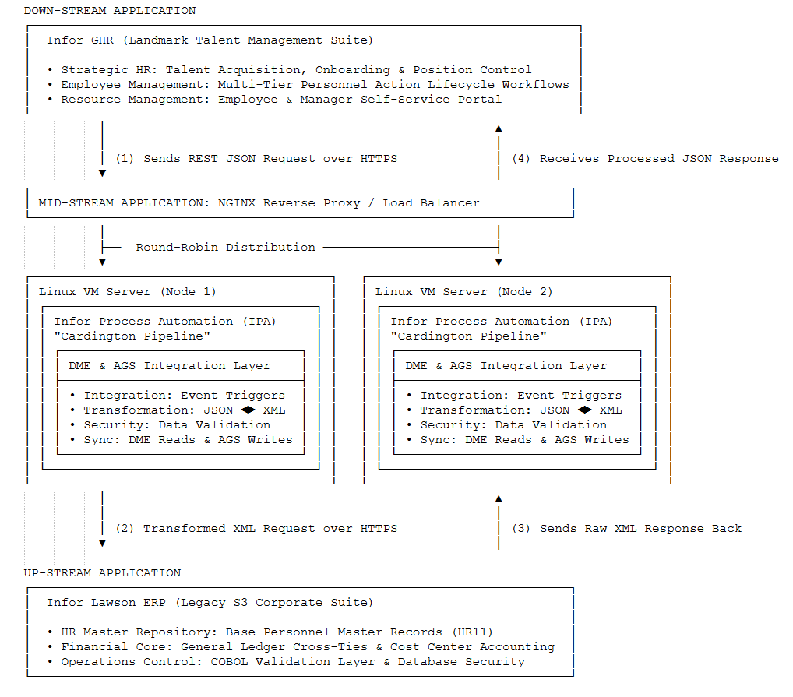
- CI/CD DEPLOYMENT PIPELINE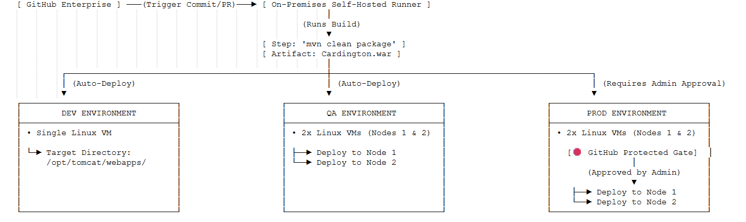System Services Control & Logs
sudo /usr/bin/systemctl status cardington.service
- sudo /usr/bin/systemctl stop cardington.service
- sudo /usr/bin/systemctl start cardington.service
- Logs Location - /opt/cardington/log/cardington.log
Knowledge Transfer Summary
Overview
Key participants in this meeting include Keith Boggs, Venkat Deverakonda, Daniel Joseph, and members of the ERP SRE team such as Yashraj Singh and Shivakarthik Kumar. The primary focus is on the Cardington application, a Java Spring Boot API-based system that serves as a read-only intermediary between the Lawson ERP system and the GHR portal, delivering critical HR data.
Keith Boggs provides foundational information about Cardington's deployment environments and monitoring setup, emphasizing disk space and log management as key operational concerns. Venkat Deverakonda elaborates on Cardington's architecture, data flow, and deployment processes, highlighting its stability and minimal SRE intervention needs aside from log maintenance. The team discusses monitoring via Dynatrace dashboards and synthetic checks, noting the absence of a UI limits synthetic monitoring to server and port health.
Infrastructure details reveal two nodes behind an F5 load balancer managed by Unix and F5 teams, with the ERP infrastructure team supporting the application layer. Access management, including GitHub repository permissions and distribution list inclusion, is addressed with commitments from Daniel Joseph and Venkat to facilitate onboarding and documentation sharing.
The business impact of Cardington downtime is underscored as severity one, affecting HR data accuracy on the GHR portal. Firewall and network access are confirmed to be appropriately configured, requiring only SSH access for server management. The meeting concludes with consensus that no further sessions on Cardington are necessary unless new questions arise, and participants are encouraged to reach out for follow-up.

Detailed Summary
Cardington Application Overview
Keith Boggs introduces the Cardington application, explaining it resides on the on-base proxy servers with dev, QA, and production environments. The application is monitored similarly to on-base proxy, with specific attention to disk space and log directories that could fill up and require developer intervention. Deployment is supported but infrequent, and the application is stable with basic monitoring in place.
- Keith Boggs explains Cardington lives on on-base proxy servers with dev, QA, and production nodes.
- Keith Boggs notes disk space and log directory usage as primary operational concerns.
- Keith Boggs states deployment for Cardington is supported but rarely performed.
- Keith Boggs confirms Cardington is monitored like on-base proxy.
Monitoring and Synthetic Checks
Discussion centers on monitoring Cardington via Dynatrace dashboards and synthetic monitors. Keith clarifies that Cardington lacks a browser UI, so synthetic monitoring is limited to server and port availability checks rather than UI interactions. Alerts focus on server health metrics, and the team reviews how to access these dashboards and alerts.
- Keith Boggs shows Dynatrace dashboards monitoring Cardington server and Apache Tomcat.
- Yashraj Singh confirms no specific synthetic dashboard exists; monitoring is via server alerts.
- Keith Boggs explains synthetic monitors check server ports and uptime, not UI components.
- HSKP FLR21 Train 1 confirms Cardington is API-based without a UI, limiting synthetic monitoring scope.
Cardington Data Flow and Architecture
Venkat Deverakonda provides a detailed explanation of Cardington's role as a Java Spring Boot web application that uses APIs to pull HR-related data from Lawson via DME queries. Cardington serves as a read-only intermediary between Lawson and the GHR portal, delivering employee details, PTO balances, and other HR data. The architecture is one-way, with no UI, and closely parallels the on-base proxy setup.
- Venkat Deverakonda describes Cardington as a Java Spring Boot app with no UI, using APIs.
- Venkat explains Cardington pulls data from Lawson using DME queries for HR information.
- Venkat clarifies GHR portal calls Cardington APIs to display employee data.
- Venkat confirms the architecture is one-way: GHR calls Cardington, which reads Lawson data.
Deployment and CI/CD Process
The team discusses deployment processes for Cardington, confirming it uses GitHub repositories with GitHub Actions for CI/CD. Venkat mentions upcoming deployments and that SRE involvement mainly includes approving deployments. Access to GitHub Enterprise and specific repositories is managed by an administrator, with plans to add team members accordingly.
- Venkat Deverakonda confirms Cardington deployments use GitHub Actions for CI/CD.
- Keith Boggs notes deployment process is similar to on-base proxy.
- Venkat states SRE team mainly approves deployments without manual intervention.
- Venkat and Keith discuss access management to GitHub Enterprise and repositories.
Operational Issues and Log Management
The primary operational issue identified is log files filling up disk space, which can cause application hangs. Venkat and Keith emphasize the need to monitor and clear logs regularly. The log directory is isolated per application mount point, so issues affect only Cardington. No major incidents have occurred in recent years aside from log-related problems.
- Venkat Deverakonda highlights log files consuming disk space as main operational issue.
- Keith Boggs explains each app has isolated mount points to contain log space issues.
- Venkat confirms clearing logs and restarting services resolves application hangs.
- Keith and Venkat report no P1 or P2 incidents in past years except log-related issues.
Infrastructure and Load Balancing
The infrastructure includes two nodes behind an F5 load balancer with a VIP configured. The Unix admin team manages servers, and the F5 team manages the load balancer. The ERP infrastructure team supports the application layer. Adding nodes requires coordination with development and infrastructure teams, but current traffic does not necessitate scaling.
- Keith Boggs and Venkat Deverakonda confirm two nodes behind an F5 load balancer with VIP.
- Daniel Joseph states Unix team manages servers; F5 team manages load balancer.
- Keith notes ERP infrastructure team supports the application layer.
- Venkat and Keith agree no additional nodes are currently needed due to stable traffic.
Access, Communication, and Documentation
The team discusses access to GitHub repositories, distribution lists, and communication channels. Daniel Joseph commits to adding team members to relevant DLs after receiving their details. Venkat will share Postman collections for API testing. Documentation is maintained in GitHub wikis. The importance of introductions and coordination for smoother onboarding is emphasized.
- Daniel Joseph agrees to add team members to distribution lists after receiving info.
- Venkat Deverakonda will share Postman collections for Cardington APIs.
- Documentation is available in GitHub repository wikis.
- Team stresses need for introduction meetings to streamline access and communication.
Business Impact and Criticality
Venkat and Keith explain that Cardington is critical for delivering accurate HR data to the GHR portal. Any downtime results in incorrect or missing data, impacting business operations and users. While less critical than Lawson itself, Cardington is still considered a severity one/priority one application requiring prompt attention if issues arise.
- Venkat Deverakonda states Cardington downtime affects HR data accuracy on GHR portal.
- Keith Boggs emphasizes Cardington's criticality despite being less critical than Lawson.
- Both agree issues require immediate attention due to business impact.
- Understanding Lawson is essential to grasp Cardington's role and dependencies.
Firewall and Network Access
The team confirms that firewall rules are already configured to allow necessary API communications. SSH access on port 22 is required for server management. No additional ports need to be opened for Cardington APIs, which are accessed via API calls without a UI. Network access is straightforward and secured.
- Keith Boggs confirms firewall ports are open for Cardington API communication.
- Venkat Deverakonda states SSH on port 22 is needed for server access.
- APIs are accessed via tools like Postman or curl without UI.
- No extra ports need to be whitelisted beyond existing configurations.

